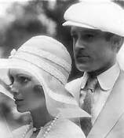
F. Scott Fitzgerald’s
The Great Gatsby
A chapter guide to the vocabulary and references used in the novel.

Cover Artwork
Francis Cugat, a little-known artist, was commissioned to illustrate the novel while Fitzgerald was in the midst of writing it. Fitzgerald approved of the cover and is said to have decided to write the giant floating face into his novel. Fitzgerald’s friend Ernest Hemingway wrote in his novel A Moveable Feast that when Fitzgerald lent him a copy of The Great Gatsby to read, Hemingway immediately disliked the cover, but "Scott told me not to be put off by it, that it had to do with a billboard along a highway in Long Island that was important in the story. He said he had liked the jacket and now he didn't like it.” Can you find the hidden naked ladies within the picture?
Title page inscription
The lines by Thomas Parke D’Invilliers were actually written by Fitzgerald. D’Invilliers is a character in Fitzgerald’s novel This Side of Paradise and was based on the writer John Peale Bishop, a Princeton classmate of Fitzgerald’s.
Chapter One
“Whenever you feel like criticizing any one, just remember that all the people in this world haven’t had the advantages that you’ve had.”- What does this piece of advice indicate about our narrator?
“The Dukes of Buccleuch”- Nick’s family likes to say that they are descended from this noble royal family line. They use this story to explain their wealth rather than the truth, which is they obtained their money from the family hardware business.
“hardboiled painting that hangs in father’s office”- The word hardboiled refers to a person who has gone through a lot of experiences. Nick’s uncle is portrayed as stern, tough, and severe.
“Teutonic migration known as the Great War”- Teutonic refers to Germany. The Great War is World War I which lasted from 1914-1918.
“bond business”- A Wall Street trading job. Nick is a stockbroaker.
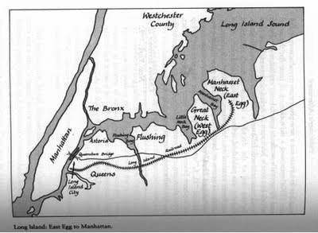
The West Egg- The West and East Eggs in The Great Gatsby are fictional, but many consider the Great Neck of Long Island to be the basis for West Egg. This is the side of the island where Nick Carraway lives and is the less classier of the two.
The East Egg- modeled after LittleNeck, Long Island. This is the more affluent of the two areas and the one where Daisy and Tom Buchanan reside. East Egg is superior to West Egg because it is older and more established and the people who live there have generational wealth, while West Egg is equally as prosperous, but newly so and therefore inferior socially.
“only Midas and Morgan and Maecenas knew”- The Greek King Midas was given one wish by the God Dionysus. Midas wished that everything he touched would turn to gold. J.P. Morgan was an American banker who became one of America’s first billionaires. Maecenas was a Roman patron of arts and and advisor to Caesar Augustus (Julius Caesar’s nephew, Octavius). His name has become a byword for a wealthy, generous, and enlightened patron of the arts.
“epigram”- A witty saying
“like the egg in the Columbus story”- This is a reference to a tale about Christopher Columbus, who is said to have challenged one of his critics to balance an egg on its tip. When the man failed, Columbus crushed the tip of the egg slightly, flattening it so that the egg could stand. By doing so, he proved that a discovery seems obvious only after it has been made by someone with the vision to imagine it.
“Hôtel de Ville in Normandy”- The building is an old, established town hall in the French province dating back to 1357.
“my second cousin once removed”- A second cousin shares the same great grandparent. The term removed means the two are from different generations.
Supercilious- haughty, disdainful, contemptuous
Fractiousness- readily angered, unruly
“I always had the impression that he [Tom] approved of me and wanted me to like him with some harsh, defiant wistfulness of his own.”- Why might Tom seek Nick’s approval?
“Almost any exhibition of complete self-sufficiency draws a stunned tribute from me.”- Nick was so used to seeing girls like Daisy who relied on their man for everything. So seeing a girl like Jordan Baker who can do things on her own is worthy of praise in Nick’s eyes.
Wan- pale
Contemptuously- a strong dislike for
“the longest day of the year”- This refers to the Summer Solstice in June when the planet’s axis is closest to the sun and the most hours of sunlight can be had.
“Have you read ‘The Rise of the Colored Empires’ by this man Goddard”- Tom is actually referring to The Rising Tide of Color Against White World-Supremacy which was written by Theodore Lothrop Stoddard in 1920. In The Rising Tide of Color, Stoddard blasted the Germans’ idea of ethnic supremacy which he felt started the First World War. He opposed the idea of White/European infighting, which he thought would make the world vulnerable to a colored uprising.
Complacency- satisfaction with a situation
“Well, he wasn’t always a butler; he used to be the silver polisher for some people in New York that had a silver service for two hundred people.” It seems like Daisy has heard enough about the Nordic race for one night, and is eager to have a chance to gossip. Her story about the butler’s nose seems random, though the fear of losing one’s position is one of the major themes of the novel. It is also possible that this was just a made up story to escape the uncomfortable truth that Tom is talking to his mistress in the other room.
Extemporizing- To improvise; to say something without having made any preparation
“To a certain temperament the situation might have seemed intriguing- my own instinct was to telephone for the police.”- Everyone in the room knows that Tom is cheating on his wife and was talking to his mistress on the phone during the dinner party. To some, this situation would seem fascinating, but to Nick it is cause for concern.
Cynical- distrustful
“’Alright,’ I said, ‘I’m glad it’s a girl. And I hope she’ll be a fool-that’s the best thing a girl can be in this world, a beautiful little fool.’” Why does Daisy want her daughter to grow up to be a fool? What does she mean?
Contributary- similar
Rotogravure- Refers to a section of newspaper containing only photographs
banns- A word meaning “proclamation.” Banns refers to the public announcement in a Christian church notifying the community of an impending marriage between two people, the purpose of which is to prevent marriages that are invalid due to a pre-existing marriage, a vow of celibacy, a lack of consent, or the couple's being related. Nick is saying that gossip has been treated like fact, and this gossip says that he is engaged to be married.
“Involuntarily I glanced seaward-and distinguished nothing except a single green light, minute and far war, that might have been the end of a dock.”- This light is an important recurring symbol in the novel. The color green is often associated with envy, and money, but here the green light may represent the American Dream, and the futility of chasing it. The light is often described as seeming so close, but always just out of reach, and that is also a good way of describing the American dream itself.
Chapter Two
“a valley of ashes”- An industrial, commercial, and working class area. The word valley conjures the image of a lush, green, pastoral scene full of life, while the word ashes implies death. This is where extreme poverty exists.
“the eyes of Doctor T.J. Eckleburg”- a billboard advertisement for an optometrist
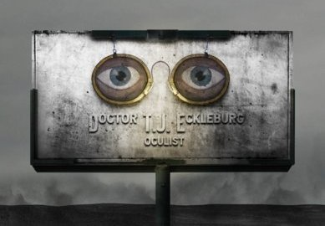
“in the borough of Queens”- Queens is the largest of the 5 boroughs (or divisions) of New York City
Supercillious- arrogant
Stout- thickset, heavy
Crêpe-de-chine- light, smooth, silk fabric
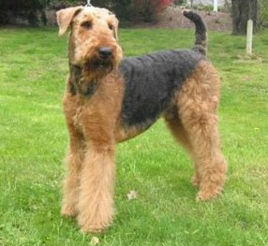
John D. Rockefeller- Was a wealthy oil magnate and well-known philanthropist during the time.
Airedale- is the largest breed of the terrier type that originated in Airedale, a geographic area in Yorkshire, England.
Myrtle Wilson- She is Tom’s mistress. A myrtle is a weed-like plant that grows upward. Myrtle is not a “Daisy.” Daisies are pure white flowers with a gold center.
“I have been drunk just twice in my life, and the second time was that afternoon…” Do you believe this about Nick? Does Nick seem like a reliable narrator?
Simon Called Peter- This is Robert Keable’s novel which was a bestseller in 1921. The title refers to Simon Peter the apostle, but the book is actually about a young British pastor who became a chaplain during World War I. Rather than dealing with interactions between the chaplain and combat soldiers, the novel goes into the young chaplain's struggles with his faith and the temptations he faces while being stationed in France. Nick Carraway says of the book “that either it was terrible stuff or the whiskey distorted things, because it didn’t make any sense…” Fitzgerald is giving the ultimate slam by negatively reviewing Keable’s work in his own novel.
Kaiser Wilhelm- The ruler of Germany during World War I
“You see…It’s really his wife that’s keeping them apart. She’s Catholic, and they don’t believe in divorce.”- Tom has lied to Myrtle. He says that Daisy is Catholic to explain why he can’t leave his wife to marry Myrtle. Really, Tom has no intention of giving up Daisy for someone as socially inferior as Myrtle.
Kike- a derogatory slur used to refer to Jews
Versailles- a 17th century French palace built outside of Paris by King Louis XIV
“…I was standing beside his bed and he was sitting up between the sheets, clad in his underwear, with a great portfolio in his hands.”- Nick’s presence in Mr. McKee’s bedroom while McKee is in bed clad only in his underwear has perplexed many readers. Some believe that this scene suggests Nick Carraway’s homosexual or bisexual nature.
Chapter Three
Aquaplanes- a water-skiing board
“cataracts of foam”- in this case the word cataracts doesn’t mean “film over the eye” but refers to a series of river rapids and small water falls.
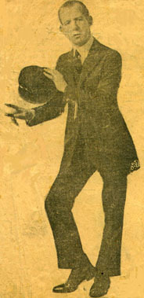
Omnibus- A means of transportaion which moves omni, or all
Cordials- A type of alcoholic drink
Castile- A region of North Central Spain. Spain is known for its beautiful shawls.
“moving her hands like Frisco”- Is a reference to Joe Frisco, an American vaudeville performer who first made his name on stage as a jazz dancer. His popular jazz dance act (called by some the “Jewish Charleston”) was a choreographed series of shuffles, camel walks and turns. He wasn’t a graceful dancer, but he attracted attention because he was fun to watch.
“Gilda Gray’s understudy from the Follies”- Gilda Gray was a Polish American actress and dancer who became famous in the U.S. for popularizing a dance called the "shimmy" which became fashionable in 1920s films and theater productions. The Ziegfeld Follies was a cross between a Broadway show and a high class Vaudeville variety show. It ran from 1907-1931.
Vehemently- done forcefully and with conviction
“…and we sat down at a table with the two girls in yellow and three men, each one introduced to us as Mr. Mumble.”- Their names are not actually Mr. Mumble. Either Nick can’t hear their names over the noise of the party, and they sound mumbled, or the person who introduces them is intoxicated and mumbles their names. There is even the possibility that the person doesn’t really remember their names and mumbles them so that he won’t be caught out.
Croirier’s- This is a fictional store, perhaps inspired by the famous jewelry store Cartier.
Innuendo- improper of suggestive language
Homogeneity- similar in nature
“spectroscopic gayety”- Spectroscopic is the study of spectra (or ranges) and gayety refers to happiness. When blended together the phrase suggests something like “the happiness spectrum.” The boisterousness of the gathering is seen as an observable sign that Gatsby is from “new money” and is therefore looked down upon by the residence of East Egg.
Cynical- skeptical, distrustful
Melancholy- Sad
Impetuously- impulsively
Ascertain- verify
“Absolutely real-have pages and everything. I thought they’d be a nice durable cardboard.”- The Owl-Eyed man expects the books on Gatsby’s bookshelf to be fake. During the 1920’s people often displayed empty book cases to appear more scholarly and intellectual.
“Volume One of the ‘Stoddard Lectures’”- John Stoddard wrote ten volumes of lectures which covered every subject from art to architecture, to archeology and natural history. He was a proponent of the restoration of the Jews to Israel. His son, Theodore Lothrop Stoddard, was racist and anti-Semitic. Notice that we are told that Gatsby reads the work of John Stoddard, while Tom reads that of Theodore Lothrop Stoddard.
Belasco- David Belasco was a theatre director and playwright who was famous for his realistic sets. “Owl Eyes” thought that like many of the newly wealthy class, Gatsby had built a library (a set) and filled the shelves with pieces of wood painted to look like books (props), thereby creating something that the established rich would own. “Owl Eyes” is shocked that Gatsby cares enough to stock his fantastic Gothic library with real books. Although this makes Gatsby appear like a member of the highest class, Gatsby has never read any of the books, as he “didn’t cut the pages.” The books in Gatsby’s library are rare first editions, in which the sheets are folded into pages but not yet cut apart.
“the banjo or the traps”- traps are drums
Hydroplane- a boat
“Vladimir Tostoff’s Jazz History of the World”- This is an imaginary song by a fictional composer. Fitzgerald may have been punning on the expression “tossed off” which means to do something quickly. Notice how the music quickly takes the party from mild to wild.
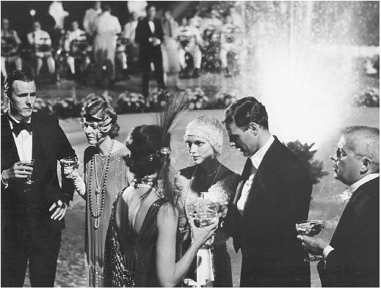
Convivial- sociable
“Eluding Jordan’s undergraduate, who was now engaged in an obstetrical conversation with two chorus girls, and who implored me to join him, I went inside.”- In other words, Jordan Baker’s companion is engaged in an inappropriate, sexual conversation with two women and Nick wants no part of it.
Vinous- The work vino means “wine” in Italian, so vinous means “wine-induced.”
Indignant- angry, furious
Sheepishly- embarrassed
Malevolent- wicked, evil
Abstractedly- preoccupied
Tumultuous- noisy and unrestrained
“a discordant din”- an unpleasant, persistent noise
“’I know very little about driving-next to nothing. It happened, and that’s all I know.” These lines are said by Owl Eyes as he explains what he knows concerning the car accident that has severed the wheel off of the automobile in which he was riding. The car was driven by a drunk driver who crashed the vehicle in a ditch near Gatsby’s property. Owl Eyes and the driver emerge from the wreckage and take no resposibility for their actions. This is the first of five references to driving mishaps in The Great Gatsby.
Caterwaulling- a loud howl or cry
Crescendo- an increase in volume
Chasms- craters
Conscientious- painstaking
“Again at eight o’clock, when the dark lanes of the Forties were five deep with throbbing taxicabs, bound for the theater district, I felt a sinking in my heart.”- Here the forties refer to the streets in New York City (most likely 42nd street which was known for its theatres, especially near the intersection of Broadway and Times Square). Some believe forties may also refer to the types of cars themselves which could go forty miles per hour. The word throbbing describes the rumbling of the vehicles.
Affectations- unnatural behavior meant to impress
Row- a fight
Subterfuges- deceptions
“You’re a rotten driver”- Nick says of Jordan who passes so close to some workmen that the fender flicked a button on one man’s coat. This is the second of five driving mishaps that occur in the novel. Jordan also does not take any responsibility for her actions and replies, “They’ll keep out of my way… it takes two to make an accident.” Does it? This conversation is important and foreshadows other events in the story.
“Everyone suspects himself of at least one of the cardinal virtues, and this is mine: I am one of the few honest people that I have ever known.”- Is Nick really honest or is he deluding himself? Why or why not?
Chapter Four
Bootlegger- A seller of illegal merchandise. In this case, Gatsby is believed to sell liquor which is outlawed by Prohibition. The term bootleg refers to concealing objects in the leg of a high boot.
Von Hindenburg- Was the German President and the commander of the German forces during World War I.
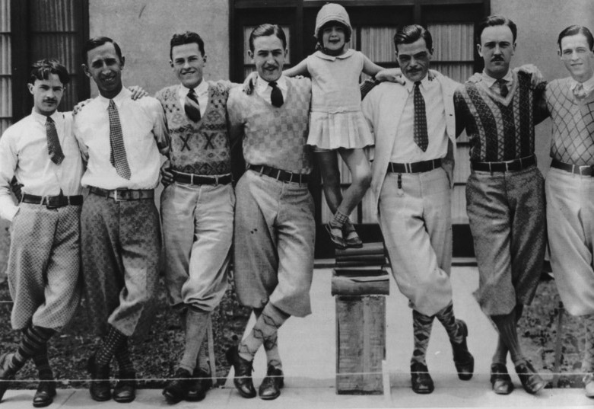
Knickerbockers- These were short, loose-fitting pants gathered at the knee. They were considered fashionable menswear during the 1920’s.
“Snell was there three days before he went to the penitentiary, so drunk out on the gravel drive that Mrs. Ulysses Swett’s automobile ran over his right hand.”- This is the third of five car-related mishaps in the novel. The first was done by a drunk driver whose passenger was the Owl Eyed man, and the second offense was committed by Jordan Baker when she carelessly swiped a workman with the fender of her car which prompted Nick to call her “a rotten driver.”
“old sport”- Is an English term of endearment. Being an Oxford man, Gatsby could have picked this saying up during his education. Throughout the novel it becomes clear that this is Gatsby’s catchphrase, and he frequently uses it when talking to Nick Carraway, which shows that Gatsby respects him.
Punctilious- Careful about correct behavior; showing great care in small details.
“He saw me looking with admiration at his car.” Gatsby drives a spectacular-looking cream colored Rolls Royce.
“’What part of the Middle West?’ I inquired casually. ‘San Francisco.”- Nick is sceptical of Gatsby’s response. Why?
rajah- A king or prince in India
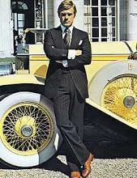
Incredulous- skeptical
“The very phrases were worn so threadbare that they evoked no image except that of a turbaned ‘character’ leaking sawdust at every pore as he pursued a tiger through the Bois de Boulogne”- Nick imagines a mental version of Gatsby that is entertaining. In it, Gatsby is dressed wrong (turbaned), for his surroundings (France). This is one way that Nick suggests the falsity of Gatsby’s history. Nick then alludes to Gatsby’s futile attempt to pass himself off as a member of old wealth by suggesting that Gatsby is chasing a tiger through the “Bois de Boulogne,” which is a park in Paris. In essence, Nick thinks that Gatsby is a fraud who is out of place, pursuing impossible things. His sideways glances, inappropriate smiles, and his threadbare, overused phrases indicate that he’s lying.
“Orderi de Danilo”- This means Order of Prince Danilo who was the first ruler of the kingdom of Montenegro.
Montenegro- A small, fiercely independent kingdom now part of Yugoslavia.
Astoria- A commercial, industrial, and residential section of Queens, a borough in New York named after John Jacob Astor. Astor was an American businessman, real estate builder, investor, inventor, and writer. On April 15, 1912, Astor, along with 1,514 other people, died on board The Titanic. Not only was he the richest passenger aboard the vessel, but he was also considered to be the richest person in the world at that time.
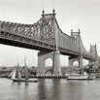
Queensboro Bridge- This bridge over the East River connects the boroughs of Manhattan and Queens in New York City.
“Over the great bridge, with the sunlight through the girders making a constant flicker upon the moving cars, with the city rising up across the river in white heaps and sugar lumps all built with a wish out of non-olfactory money. The city seen from the Queensboro Bridge is always the city seen for the first time, in its first wild promise of all the mystery and the beauty in the world.”- This descriptive account of the landmark bridge is designed to show New York City as being a place of opportunity. New York is different from “the Eggs” because it represents optimism and growth, having been built from a dream, and funded by money that was earned the good-old-fashioned way: by hard work.
Katspaugh- This is a pun on “cat’s paw,” a colloquialism (or popular expression) used to refer to a person who is utilized by another person as a tool.
Somnambulatory- Somn is the root for sleep, and ambulatory is the root for walk, so somnambulatory is to talk, walk, or perform any other act while asleep or in a sleep-like condition.
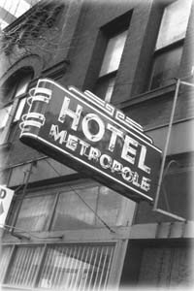
Highballs- An iced drink containing an alcoholic spirit like whiskey, plus water or a carbonated beverage like soda. Some more common highballs include: Bloody Mary, Gin and Tonic, Long Island Iced Tea, Screwdriver, and Salty Dog.
“The Old Metopole”- The Hotel Metropole, built in 1912, was the first hotel in New York City that had running water in every room. It was located at 147 West 43rd Street just off of Times Square.
Rosy Rosenthal- Herman “Rosy” Rosenthal was a real person who was killed outside the Metropole Hotel on July 16th, 1912 in much the same way that Wolfsheim describes. Fitzgerald’s readers in 1925 may have remembered this incident.
Meyer Wolfsheim- The character of Wolfsheim is believed to have been based on Arnold Rothstein, (aka “The Brain”). Rothstein was a Jewish-American racketeer who became a kingpin of the Jewish mob. He was the first to realize how profitable Prohibition could be.
Gonnegtion- Wolfsheim means connection. He also says Oggsford instead of Oxford. Fitzgerald gives Wolfsheim a dialect to suggests that he is a seedy character, and one who would not only use a vulgar pronunciation if there were one, but is at the level of ignorance where he probably misspells in this fashion, hence mispronounces as well.
Succulent- juicy, tasty
“Miss Baker’s a great sportswoman, you know, and she’d never do anything that wasn’t all right.” Here Gatsby speaks positively about Jordan’s character, but what evidence is there to support that she isn’t as upstanding as Gatsby asserts?
“Finest specimens of human molars”- Wolfshiem is a predator. Not only is he a gangster who has people killed, he also wears accessories (cuff links made of teeth) which are remnants of death.
“Yeah, Gatsby’s very careful about women. He would never so much as look at a friend’s wife.”-Meyer Wolfsheim describes Gatsby as being cautious around women. Why do you suppose this is so?
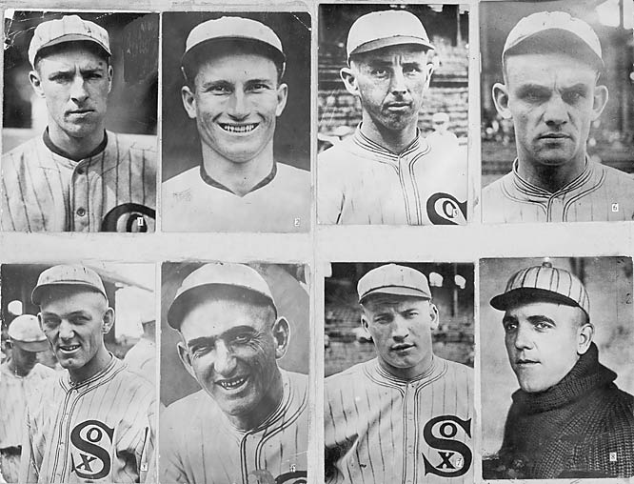
“Mr. Wolfsheim raised his hand in a sort of benediction.” In other words, his gesture was similar to what one would do when closing a prayer.
Denizen- resident
“He’s the man who fixed the World Series back in 1919.”- In 1919 the Chicago White Socks lost the World Series to the Cincinnati Reds. Eight White Socks players were later accused of intentionally losing the game in exchange for around $20,000 (per player) from gamblers. Arnold Rothstein supplied the money. The eight players became known as “The Black Sox.”
Roadster- This is a small, open car with one seat for two to three people; an earlier version of the sports car.
Début- This is a formal introduction of a young woman into society.
Armistice- This means a break in fighting, a truce in a war to discuss terms for peace and refers to November 11, 1918, which is the day World War I ended.
“I saw them one spring in Cannes, and later in Deauville”- Cannes and Deauville are both resort cities. The former is on the French Riviera and the latter is on the English Channel.
“The week after I left Santa Barbara Tom ran into a wagon on the Ventura road one night, and ripped a front wheel off his car. The girl who was with him got into the papers, too, because her arm was broken-she was one of the chambermaids in the Santa Barbara Hotel.”- Tom was cheating on Daisy just months after their wedding. This is the fourth mention of a car-related accident in The Great Gatsby.

“The modesty of the demand shook me. He had waited five years and bought a mansion where he dispensed starlight to casual moths-so that he could ‘come over’ some afternoon to a stranger’s garden.”- Nick is surprised to learn that Gatsby purposely bought the mansion across from Daisy’s and holds lavish parties in the hope that one day Daisy might attend and they can be reunited. Since that has yet to happen, Gatsby wants Nick to arrange a meeting between Daisy and himself.
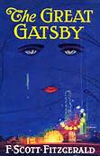
“We left the Plaza for half an hour and were driving in a victoria through Central Park”- A victoria is a horse-drawn carriage for two named after Queen Victoria who ruled England from 1837-1901.
“Unlike Gatsby and Tom Buchanan, I had no girl whose disembodied face floated along the dark cornices and blinding signs…”- This quote by Nick Carraway at the end of Chapter IV, captures the meaning behind the cover artwork of Fitzgerald’s novel. Some maintain that the image is supposed to be of Dr. T.J. Eckelburg’s billboard, but clearly it is the face of a woman.
Chapter Five
World’s Fair- The World’s Fair are large expos that are held around the world and have extravagant features such as pavilions and goods that people are selling. There have been World Fairs in cities such as New York, London, and Tokyo. The next World Fair will be held in Milan, Italy in 2015.
Coney Island- is a residential neighborhood, peninsula, and beach on the Atlantic Ocean in southwestern Brooklyn, New York City. The site was formerly an outer barrier island, but became partially connected to the mainland by landfill. Coney Island is well known as the site of amusement parks and a seaside resort. The attractions reached their peak during the first half of the 20th century, declining in popularity after World War II and years of neglect.
“Well, suppose we take a plunge in the swimming-pool? I haven’t made use of it all summer.”- Gatsby has a house full of people every night and all he wants is one friend to go swimming with him.
“I realize now that under different circumstances that conversation might have been one of the crises of my life. But because the offer was obviously and tactlessly for a service to be rendered, I had no choice except to cut him off there.”- Gatsby has just invited Nick to take part in a business deal-most likely a criminal enterprise-which Nick has refused. Nick says that had he been in a different mood, or had Gatsby approached the conversation in a different manner, he might have agreed, which would have been a disaster.
“I had forgotten to tell my Finn to come back…”- Nick is referring to his Finnish housekeeper.
“That’s the secret of Castle Rackrent”- Castle Rackrent is a short novel by Maria Edgeworth. It is said to be the first novel in which the narrator is an observer rather than a player in the story that the character belongs to. Nick, the narrator of The Great Gatsby, will act as an observer to the reunion between Daisy and Gatsby.
“Does the gasoline affect his nose?”- Nick is teasing Daisy about her chauffeur. This is a reference to a conversation in Chapter 1 when Daisy said that her butler “used to be the silver polisher for some people in New York that had a silver service for two hundred people. He had to polish it from morning till night, until finally it began to affect his nose.” Daisy’s response to this question indicates that she had most likely been making up the original story about the butler.
“I’m sorry about the clock.”- Gatsby nervously leans against the clock on the mantle, knocks it over, and catches it with trembling fingers. This incident not only shows how nervous Gatsby is, but also represents his clumsy attempt to recapture his past.
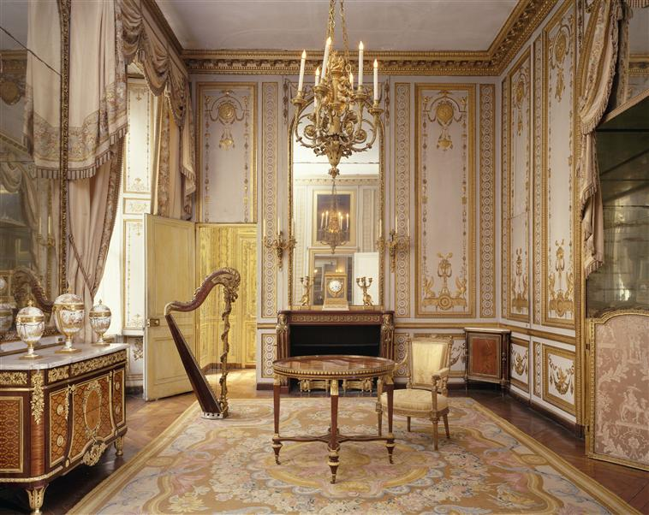
“There was nothing to look at from under the tree except Gatsby’s enormous house, so I stared at it, like Kant at his church steeple, for half an hour.” Immanuel Kant (1724-1804), the German philosopher, said that he developed his theories regarding reality and morality while gazing at a church steeple outside his window.
Postern- A back door or gate; a private entrance
Feudal- Pertaining to the middle ages
Jonquils- Yellow, fragrant flowers that look like daffodils and bloom in March or April
Hawthorn- Thorny trees with small, reddish fruit
Kiss-me-at-the-gate- A Chinese honeysuckle
“Marie Antoinette music-rooms and Restoration salons”- These are two styles that are associated with spectacular wealth. Marie Antoinette is a style typical of the period just before the French Revolution in 1789. It is characterized by gold embellishments and colorful patterns that exemplify grandeur. Restoration, refers to an English style that incorporates exotic and ornate detailing. By using both styles, Gatsby appears wealthy and cultured, which makes him all the more appealing to people of old wealth, like Daisy.
“As Gatsby closed the door of ‘the Merton College Library’ I could have sworn I heard the owl-eyed man break into ghostly laughter.” The Merton College Library is one of the earliest libraries in Oxford, England. Nick is recalling both the Owl Eyed man’s incredulous response to Gatsby’s book collection as well as jokingly referring to Gatsby’s past as a student of Oxford University.
Mr. Klipspringer- Klipspringer is a character in the novel who is also referred to as “the boarder” because he appears to be homeless and living at Gatsby’s home.
Adam study- The Adams were an eighteenth-century Scottish family of architects who developed a new architectural style. The Adam style is identified with classical Roman decorative motifs, such as framed medallions, vases, urns, sphinxes, griffins, and dancing nymphs. The style was strongly influenced by frescoes and wall paintings found in the newly excavated Roman cities, Etruscan Greek black and red vases, which were being excavated and collected in large numbers, and classical Greek architecture.
Chartreuse- Chartreuse is a French liqueur that has 130 herbs distilled in it. Its color is a yellow green.
“His bedroom was the simplest room of all-except where the dresser was garnished with a toilet set of pure dull gold.”- What does it say about Gatsby that his private room is so simply decorated when the rest of his house is ornate?
They’re such beautiful shirts,” she sobbed, her voice muffled in the thick folds. “It makes me sad because I’ve never seen such-such beautiful shirts before.” Why is Daisy really crying? What do those shirts represent? How do Daisy’s tears differ from what Gatsby is feeling?
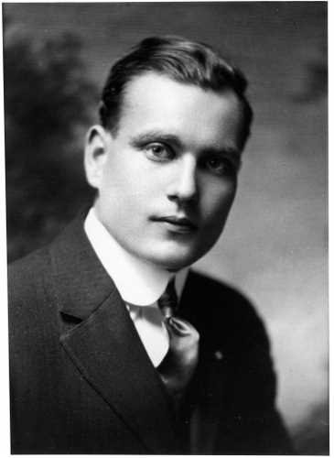
“Possibly it had occurred to him that the colossal significance of that light had now vanished forever. Compared to the great distance that had separated him from Daisy it had seemed very near to her, almost touching her. It had seemed as close as a star to the moon. Now it was again a green light on a dock. His count of enchanted objects had diminished by one.”- What was the significance of the green light and why does it vanish for Gatsby at this moment? What does the last line of this quote mean?
Pompadour- A hairstyle in which the hair is combed back to create the illusion of a puffy mass in the front.
“I was going to ask to see the rubies when the phone rang”- Nick is poking fun at these relics of Gatsby’s past.
“I saw that the expression of bewilderment had come back into Gatsby’s face, as though a faint doubt had occurred to him as to the quality of his present happiness. Almost five years! There must have been moments even that afternoon when Daisy tumbled short of his dreams — not through her own fault, but because of the colossal vitality of his illusion.”- Nick believes that at some point Gatsby will realize that the Daisy-of-his-dreams was a fantasy, and that the real Daisy is a disappointment. What do you think is the cause of Gatsby’s “bewilderment” in this line? Is Nick correct…does Gatsby now realize that he has overvalued Daisy?
“I think that voice held him most, with its fluctuating, feverish warmth, because it couldn’t be over-dreamed-that voice was a deathless song.”- Daisy’s voice is the most striking quality she possesses and one that Gatsby couldn’t have over-imagined, or one that he could ever forget.
Chapter Six
Laudable- praiseworthy; admirable
The “underground pipe-line to Canada”- This is a reference to a bootlegging scandal involving alcohol being sent through an underground pipeline from Canada.
“James Gatz-that was really, or at least legally, his name.”- Not until Chapter VI, more than halfway through the novel, do we learn of Gatsby’s past. James Gatz erases his obscure family name as well as his humble past, by transforming himself into Jay Gatsby. In a sense, Gatsby wants to figuratively make a name for himself. Coincidentally, the name “Gatsby” sounds like “God’s boy,” which relates to Gatsby’s godlike desire for glory, as well as his wish to shape reality. The name also may reference the Gatling gun which was one of the best known early rapid-fire weapons and a forerunner of the modern machine gun (a weapon commonly used by mobsters).
Tuolomee- This is the name of Dan Cody’s yacht. It is a fictional word designed to evoke images of exotic adventures in far-away places.
Shiftless- lacking ambition or abilities; not having the knowledge required to do something successful
Platonic conception- This is a reference to the Greek philosopher, Plato, and his notion that physical objects are inferior copies of extraordinary ideas. Gatsby’s “platonic conception” is his fantasy of a prosperous life, rather than his poor reality.
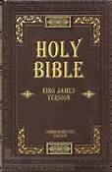
“He was a son of God -a phrase which, if it means anything, means just that- and he must be about His Father’s business, the service of a vast, vulgar, and meretricious beauty.”- He must be about His Father’s business is a quote taken right out of the Bible. In Luke 2:49-50, Jesus states, “Did you not know that I must be about my father’s business?” This quote illustrates how Jesus knew he was the son of God and destined for great things from a young age. The same quote is used to characterize Gatsby (whose name is a play on the words God’s boy) and his similar ambitions. Gatsby doesn’t believe himself to actually be the son of God, but he realizes that he is destined for greater things than being a poor North Dakota farmer, so he sets about on a mission of self-improvement. Instead of following the behavioral guidelines set in the bible, Gatsby’s business of “vast, vulgar, and meretricious (deceptive) beauty” indicates that he is more concerned with making himself into a prosperous man than a moral one.
“The most grotesque and fantastic conceits haunted him in his bed at night.”- Grotesque and fantastic are both words used to describe the Valley of Ashes. Their repetition here emphasizes Gatsby’s poverty. These conceits (dreams of self-improvement) “haunt” him to the point that he is losing sleep because he is obsessively aware of his social position and is desperate to escape it.
Reveries- dreams
“An instinct toward his future glory had led him, some months before, to the small Lutheran college of St. Olaf in southern Minnesota. He stayed there two weeks, dismayed at its ferocious indifference to the drums of his destiny, to destiny itself, and despising the janitor’s work with which he was to pay his way through.”- (Notice the alliteration in these lines.) While Gatsby has dreams of great fortune, he does not want to work for them in the traditional way. He is humiliated by the janitor’s work he did to pay for room and board at an insignificant and lowly college, so he quits. Gatsby wants his life to be a fairy tale in which glory is thrust upon him.
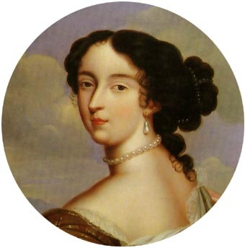
Madame de Maintenon- Maintenon was a 17th century Frenchwoman who married a much older, wealthy, and crippled man and lived off the money she inherited when he died. When she became impoverished, she was hired by her friend, the King’s mistress, to take care of their illegitimate daughter. After King Louis XIV became bored with his wife and mistress, he became fascinated by Maintenon and she became an important advisor to him. Maintenon accepted large sums of money from King Louis, who after the death of the Queen, secretly married her. Fitzgerald implies that Maintenon was a schemer, and draws a connection between her and Dan Cody’s girlfriend Ella Kaye, who used Cody for his money and “sent him to sea” so she could bask in his wealth. We are told that Cody dies “inhospitably” one week after Ella Kaye boards his yacht, and that she was the one who prevented Gatsby from getting his $25,000 inheritance while she inherited millions.
Reposing- laying
Inhospitably- unfriendly
Florid- red complexion
Debauchee- immoral; self-indulgent
Brothel- a house of prostitution
“It was indirectly due to Cody that Gatsby drank so little. Sometimes in the course of gay parties women used to rub champagne into his hair; for himself he formed the habit of letting liquor alone.”- Why didn’t Gatsby drink alcohol?
Antecedents- ancestors
Ingratiate- seeking to please
Senile- forgetful, confused, mentally less acute
Affected- influenced by or moved emotionally
Haughtily- arrogantly
Cordial- friendly
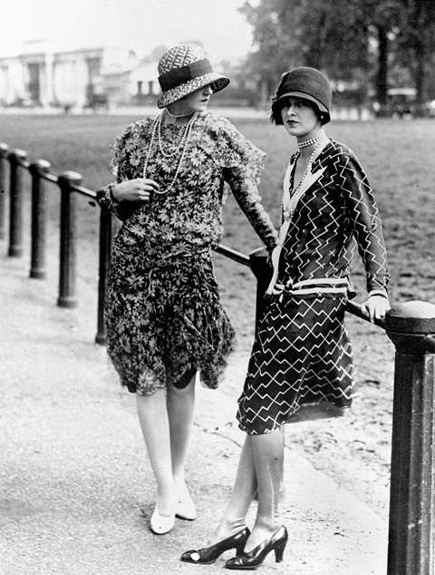
“I wonder where in the devil he met Daisy. By God, I may be old-fashioned in my ideas, but women run around too much these days to suit me. They meet all kinds of crazy fish.”- Here Tom associates Daisy with the new liberated women of the 1920s, often referred to as flappers. Ironically, while Tom is uncomfortable with his own wife traveling and socializing independently, he doesn’t seem to apply the same standards to his mistress, Myrtle. This is a prime example of Tom’s hypocrisy.
Oppressiveness- highly stressful, burdensome pressure
“I liked that man-what was his name?-with the sort of blue nose.” Blue nose is 1920’s slang meaning a puritanical person; a prude.
“Go ahead…and if you want to take down any addresses here’s my little gold pencil.” This line suggests that, although Tom claims to be going to another table for amusing conversation, he is really in pursuit of a woman and Daisy knows it. Because Daisy is engaged in a romantic relationship with Gatsby, she is no longer concerned with her husband’s actions and even offers her pencil knowing that it will most likely be used to gain another girl’s address.
Septic- Poisoned
Lethargic- Tired, drowsy
“’I like her,’” said Daisy, ‘I think she’s lovely.”- The only person Daisy likes at Gatsby’s party is the movie star and she basis her judgment on the woman’s appearance. This comment sums up Daisy’s shallow values and is reminiscent of her wish for her daughter in Chapter 1: “I hope she’ll be a fool- that’s the best thing a girl can be in this world, a beautiful little fool.” Society has judged Daisy all her life for her beauty, and this, in turn, is how she judges others.
“But the rest offended her-and inarguably, because it wasn’t a gesture but an emotion.”- Daisy, as a member of the aristocracy, is very used to living with “gestures.” These manners are fake and lack warmth, such as the times when we see Jordan Baker carefully balancing a non-existent object on her chin more than once. Gatsby’s guests don’t employ these gestures, but instead act on their “emotions.” Daisy is “offended” by the crowds’ vitality and lack of class, and she looks down on the crowd with contempt.
Vigor- energy; intensity
Chafed- worn away
Euphemism- inoffensive words
Obtrusive- noticeable
Menagerie- wild animal exhibit
Contralto- lowest female vocal range
Dilatory- slow; intending to delay
Incalculable- unable to be calculated
“He wanted nothing less of Daisy than that she should go to Tom and say: “I never loved you.” After she had obliterated four years with that sentence they could decide upon the more practical measures to be taken.”- Is this a realistic expectation? Do you think Daisy will give up her life with Tom for Gatsby?
Incredulously- Unwilling or unable to believe
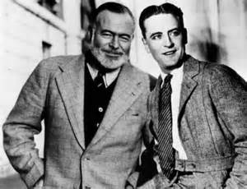
“His heart beat faster and faster as Daisy’s white face came up to his own. He knew that when he kissed this girl, and forever wed his unutterable visions to her perishable breath, his mind would never romp again like the mind of God.”- Gatsby desperately wants to kiss Daisy, but he realizes that as soon as he does, she will become a reality, and he will no longer be free to enjoy the fantasy world that he has created for them.
“Through all he said, even through his appalling sentimentality, I was reminded of something-an elusive rhythm, a fragment of lost words, that I had heard somewhere a long time ago. For a moment a phrase tried to take shape in my mouth and my lips parted…But they made no sound, and what I had almost remembered was uncommunicable forever.”-
Gatsby speaks with appalling sentimentality because he believes in hope, love, and the American dream, but many men and women became disillusioned with the world after WWI, and felt emotionally confused or “lost.” The Lost Generation was the name for a group of American artists and writers who lost the belief that America was “the land of opportunity.” They relocated to France to become expatriates. This league of writers included Hemingway, T.S.Eliot, and F.Scott Fitzgerald, the author of The Great Gatsby. Nick is similarly disillusioned. A story of true love seems like words he had once heard, but has since long forgotten. He tries to remember, but he finds it impossible.
Chapter Seven
Obscurely- unclearly
Trimalchio- He is the character of a rich, vulgar upstart taken from the satires of Petronious, the 1st century Roman writer. Fitzgerald had considered using the name Trimalchio in the title of this novel, but later reconsidered, thinking that the reference may be to obscure for readers.
Dilatory- slow; delayed
Caravansary- An oriental inn for caravans; a gaugy enterprise
“Something was up. And yet I couldln’t believe that they would choose this occasion for a scene-especially for the rather harrowing scene that Gatsby had outlined in the garden.”- Nick is wondering why they are being invited to Daisy’s house and he hopes that it isn’t to witness Daisy leaving Tom for Gatsby.
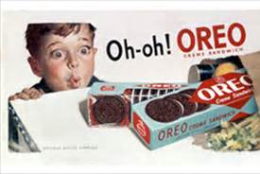
The National Biscuit Company- The National Biscuit Company is a company of over 40 different bakeries. It began in the 1890’s and made products such as Oreos, Saltine crackers, Fig Newtons, Vanilla Wafers, Animal Crackers, and several others. The company is known today as Nabisco.
Desolute- grim; joyless
Commutation- commuter
“My commutation ticket came back to me with a dark stain from his hand. That any one should care in this heat whose flushed lips he kissed, whose head made damp the pajama pocket over his heart!” What is Nick Carraway thinking here? Notice the elipses that precede and end this ambiguous scene. Fitzgerald also uses elipses at the end of Chapter II during that other strange sequence with Mr. MacKee.
“’The master’s body!’ roared the butler into the mouth-piece. ‘I’m sorry, madame, but we can’t furnish it-it’s far too hot to touch this noon!”- This is the conversation that Nick imagines that the butler is having with the person on the other end of phone. Nick believes that the caller is probably a woman requesting that Tom meet her at some seedy lodging house, and he comically envisions the butler’s outrage to such an inappropriate request. In reality, we don’t know who the butler is talking to, but what he really says is “Yes…Yes…I’ll see.”
“Very well, then, I won’t sell you the car at all…I’m under no obligations to you at all…and as for your bothering me about it at lunch time, I won’t stand that at all!”- Jordan and Daisy think that Tom is pretending to talk business when he is really talking to a girl. They’re wrong. He’s talking to the man in Chapter II who wanted to buy Tom’s car. Who is this individual?
Cynically- sarcastically; in a mocking, scornful, or sneering manner
Bona-fide- done without deception or fraud; authentic; true
“’You forget there’s a lady present,’ said Jordan. Daisy looked around doubtfully. ‘You kiss Nick too.’ ‘What a low, vulgar girl!”- Daisy has kissed Gatsby. When Jordan claims to take offense as a lady, Daisy looks around and implies that Jordan is no lady at all. Daisy then tells Jordan to kiss Nick, which embarrasses Jordan and prompts her to call Daisy “low” and “vulgar.” The characters are irritable with one another and are feeling the effects of the extreme heat
Clog- to know in a rhythmic fashion
“Afterward he kept looking at the child with surprise. I don’t think he had ever really believed in its existence before.”- Daisy’s daughter is a complication to Gatsby’s life plan, which he has purposefully ignored. She is proof that Daisy has moved on with her life, while he has not.
“’She doesn’t look like her father,’ explained Daisy. ‘She looks like me.’”- Why does Daisy pointedly make this comment?
“On the green Sound, stagnant in the heat, one small sail crawled slowly toward the fresher sea. Gatsby’s eyes followed it momentarily; he raised his hand and pointed across the bay.”- This is reminiscent of Gatsby in Chapter I when Gatsby “stretched out his arms toward the dark water in a curious way.” Gatsby is still dreaming about the idea of easy money and a lavish lifestyle.
“You always look so cool…You resemble the advertisement of the man…You know the advertisement of the man”- Daisy refers to Gatsby as “cool” (he is calm, well dressed, casual) while early in the novel she has described her husband Tom as “hot” (he’s angry, hulking, aggressive). Clearly the two men are opposites. Here, Daisy also admits that Gatsby’s facade has worked. He has managed to convince her completely that he belongs in the elite class of which she is a part. She likens him to a well-known actor, one who is the wealthiest of the wealthy.
“He was astounded. His mouth opened a little, and he looked at Gatsby, and then back at Daisy as if he has just recognized her as someone he knew a long time ago.”- It has been a while since Daisy has looked lovingly at Tom, but he remembers the look, and realizes that it is now being directed at Gatsby.
“Her voice is full of money.”- Perhaps this is why Gatsby is so in love with Daisy. Everything about her -even her voice- represents money.
“Plenty of gas…You can buy anything at a drug-store nowadays.”- This seems like a normal offhand remark by Tom, and a casual offer to Gatsby that he will refill his car if he needs it, but Tom had recently found out that Gatsby is the owner of many drug stores, and sells bootleg alcohol at these stores, so he’s making a not-so-subtle reference to that fact and it ends up being pretty effective in silencing Gatsby.
“…an indefinable expression, at once definitely unfamiliar and vaguely recognizable, as if I had only heard it described in words, passed over Gatsby’s face.” Gatsby’s look is ambiguously described, but one gets the impression that if looks could kill, Tom would be a dead man.
Keenly- strongly; clearly
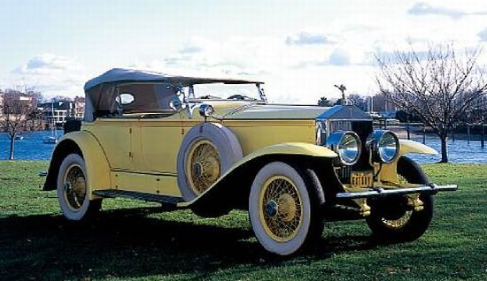
“I’m sick…been sick all day.” “You sounded well enough on the phone.”- George Wilson is upset to the point that he has become physically ill. Tom’s response to George indicates that this was the man who Tom was talking to on the phone.
“How do you like this one? I bought it last week.” “It’s a nice yellow car.”- Even Tom is jealous of Gatsby’s Rolls Royce and can’t help showing it off. Wilson’s knowledge of this car will later become an important part of the novel.
“His wife and mistress, until an hour ago secure and inviolate, were slipping precipitately from his control. Instinct made him step on the accelerator with the double purpose of overtaking Daisy and leaving Wilson behind…”- If there is one thing the reader knows about Tom in this novel, it is that he loves and needs control. This becomes clear through the way he drags Nick around the city, to his domestic abuse towards Daisy and Myrtle. At this point in the novel, Tom has no control, since his wife is speeding away with another man, and his mistress is leaving town soon.
Sensuous- physically gratifying or pleasurable
Explicable- explainable
Tumultuous- noisy; unrestrained
“You make it ten times worse by crabbing about it.”- When Tom says this to Daisy, Gatsby leaps to Daisy’s defense and says, “Why not let her alone, old sport? You’re the one that wanted to come to town.” This starts the verbal sparring match between Tom and Gatsby.
Why is it ironic that Mendelssohn’s Wedding March begins playing in the ball room below?
Appended- added; supplemented
Irreverent- disrespectful; mocking
“You must have gone there about the time Biloxi went to New Haven.” Tom is calling Gatsby a liar and a fraud by implying that he no more went to Oxford University than Blocks Biloxi went to Yale.
“I wanted to get up and slap him on the back. I had one of those renewals of complete faith in him that I’d experienced before.”- Nick really wants to like Gatsby and believe what he has to say, but all the mysteries and unanswered questions around him make this difficult. But when Gatsby addresses the rumor that he never went to Oxford with a completely reasonable response, Nick feels relieved that he can trust him again.
Armistice- Armistice marks the signing of the agreement to end the hostilities that began during WWI. The treaty took effect at eleven o'clock in the morning—the “eleventh hour of the eleventh day of the eleventh month” of 1918.
Row- fight; argument
“Nowadays people begin by sneering at family life and family institutions, and next they’ll throw everything overboard and have intermarriage between black and white.” “’We’re all white here,’ murmured Jordan.” Tom resorts to his famous “Nordic Race” rant whenever he feels that societies morals are in jeopardy. But Jordan points out how irrelevant this is to the current argument, since race has nothing to do with this issue.
“Angry as I was, as we all were, I was tempted to laugh whenever he opened his mouth. The transition from libertine to prig was so complete.”- Nick could laugh at Tom’s outraged actions because he knows that Tom is a hypocrite who complains about a lack of family values, while cheating on his own wife.
“’Your wife doesn’t love you,’ said Gatsby. ‘She’s never loved you. She loves me.”- After six chapters of slow progression to this moment, we finally reach the boiling point (fitting, since it is the hottest day of the year). Gatsby confronts Tom at last, claiming not only that Daisy would choose him, but that she never loved him in the first place. Note the certainty and finality in the way he says this. He doesn’t even consider the fact that Daisy might not agree with everything he says. He probably played this scenario through his mind a million times the last five years, but never even imagined that anything could go wrong.
“’Not seeing,’ said Gatsby. ‘No we couldn’t meet. But both of us loved each other all that time, old sport, and you didn’t know.’” “’Oh-that’s all.” Gatsby values the emotional aspect of love, while Tom only seems to value the physical side. That’s why Tom is unconcerned with what Gatsby has said.
“The trouble is that sometimes she gets foolish ideas in her head and doesn’t know what she’s doing.” This is a pretty sexist remark. Tom basically states that Daisy is just a pretty fool. Again, this takes us back to Daisy’s wish for her daughter to grow up to be a beautiful fool.
“Why-how could I love him-possibly?”- Daisy wants to leave Tom for Gatsby, but she can’t do what Gatsby asks. Gatsby needs Daisy to say that she never loved Tom in order for his fantasy to become real, but Daisy can’t do it. She may have initially married Tom for his money, but she grew to love him, and a part of her loves him still, even after he cheated on her and possibly beat her. Her question is both for herself, (How is it possible that I love this guy?) and to avoid lying to Gatsby and Tom.
“Her eyes fell on Jordan and me with a sort of appeal, as though she had never, all along, intended doing anything at all. But is was done now. It was too late.”- Clearly Daisy had never intended on jeopardizing her marriage to Tom. She had never planned on her affair coming to light and having to choose between the two men.
Kapiolani- This is the largest and oldest public park in Hawaii. Tom is bringing up special memories that the two shared to prove that Daisy loved him, but he is still defining his marriage with Daisy in economic and material terms instead of expressing emotional love.
Rancor- resentment
“’Oh, I won’t stand this!’ cried Daisy. “Oh, please let’s get out.”- Daisy will do anything she can to avoid making a final decision, especially one as important as this one, so she would rather just walk out in the middle of Tom and Gatsby’s heated dispute than choose who she is going to be with the rest of her life.
“’Walter could have you up on the betting laws too, but Wolfsheim scared him into shutting his mouth.’ That unfamiliar yet recognizable look was back again in Gatsby’s face.”- Tom has investigated Gatsby and has learned that Gatsby is involved in more criminal activity than just bootlegging, which most people already suspected. When Tom mentions Gatsby’s gambling activity, Gatsby gives him a murderous and menacing look which could lend credibility to some of the earlier rumors that he is also a murderer.
Magnanimous- generous
Contempt- scorn
Wan- pale
Formidable- difficult to deal with
Inquest- formal investigation
“He was his wife’s man and not his own.” George Wilson’s wife wears the pants in the family.
“The other car, the one going toward New York, came to rest a hundred yards beyond, and its driver hurried back to where Myrtle Wilson, her life violently extinguished, knelt in the road and mingled her thick dark blood with the dust.”- Myrtle, like Gatsby, aspires to achieve great wealth and improve her social standing. Her vitality for life is what appeals to Tom, but this quality is extinguished and her body is left in the ash from where she came and will return. The quote is reminiscent of the biblical verse (Genesis, 3:19) which says, “ashes to ashes, dust to dust,” and is used to show the futility of people like Myrtle and Gatsby who try to escape their fate.
“Michaelis and this man reached her first, but when they had torn open her shirtwaist, still damp with perspiration, they saw that her left breast was swinging loose like a flap, and there was no need to listen for the heart beneath.” This is the fifth and final reference to a car-related accident in the novel. Myrtle is killed and the car that struck her down belongs to Gatsby. The phrase “swinging loose like a flap” seems to be Fitzgerald’s criticism to the liberated woman of the twenties (the flapper). The warning: “Although you now have the right to vote, don’t take your newfound independence too far. Don’t swing too loose, because reckless behavior has consequences.”
Truculent- aggressively defiant
“’Was Daisy driving?’ ‘Yes,’ he said after a moment, ‘but of course I’ll say I was.’”- Just as in the four previous car-related accidents, Daisy, too, will not take responsibility for her actions.
“…and this woman rushed out at us just as we were passing a car coming the other way. It all happened in a minute, but it seemed to me that she wanted to speak to us, thought we were somebody she knew.” This is an example of dramatic irony. The reader knows that Myrtle believes that Tom is behind the wheel, having seen Tom driving Gatsby’s car earlier that day. Clearly, she approached the car to speak with Tom expecting it to slow, and was hit by Daisy who was startled and emotionally upset after her own confrontation with Tom.
“They weren’t happy, and neither of them had touched the chicken or the ale-and yet they weren’t unhappy either. There was an unmistakable air of natural intimacy about the picture, and anybody would have said that they were conspiring together.”- Does this seem like a natural reaction to the day’s events? What does their reaction say about them? What do you suppose Tom and Daisy are “conspiring” to do?
Chapter Eight
“I felt that I had something to tell him, something to warn him about, and morning would be too late.”- What do you think that Nick wants to tell Gatsby?
“I waited, and about four o’clock she came to the window and stood there for a minute and then turned out the light.”- Light is a recurring symbol of Daisy’s and Gatsby’s relationship, most notably in the case of the green light at the end of the Buchanan dock. When Daisy turns out the light here, she is rejecting Gatsby for good.
Pavilions- an outdoor structure: a summerhouse or other often ornamental building in a park, fair, or garden, used for shelter and entertainment
Innumerable- not easily countable
Inexplicable- unexplainable
Humidor- a container in which tobacco products, especially cigars, can be stored to prevent them from drying out
“once I tumbled with a sort of splash upon the keys of a ghostly piano. There was an inexplicable amount of dust everywhere, and the rooms were musty, as though they hadn’t been aired for many days. I found the humidor on an unfamiliar table, with two stale, dry cigarettes inside. Throwing open the French windows of the drawing-room, we sat smoking out into the darkness.”- Notice the adjectives ghostly, dust, musty, stale, dry, and darkness. The setting is reflective of the atmosphere. Gatsby’s house, once buzzing and overflowing with lively partygoers, is now dull and abandoned. Gatsby’s deteriorating house symbolizes his loss of Daisy, and his declining hope in the American dream.
“It was this night that he told me the strange story of his youth with Dan Cody—told it to me because ‘Jay Gatsby’ had broken up like glass against Tom’s hard malice, and the long secret extravaganza was played out.” The information about Gatsby’s life that Nick related in Chapter 6 is learned at this moment, the morning after Myrtle’s death. The events of the previous evening have shattered some of Gatsby’s dreams, and at this point in the novel he is finally able to be honest with Nick.

“She was the first ‘nice’ girl he had ever known.” Daisy is the first girl from established wealth that Gatsby had ever met. Perhaps one of Gatsby’s biggest flaws is his belief that the tremendous wealth these people have makes them “nice.”
Indiscernible- impossible to understand
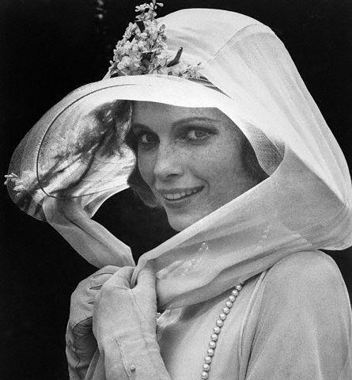
“It excited him, too, that many men had already loved Daisy-it increased her value in his eyes.”- Gatsby is attracted to Daisy because she is a popular, sought-after girl who has economic and social power that he can use to increase his own wealth and social stature
Ravenously- hungrily
Unscrupulously- without scruples, morals, or conscience
“…but he had deliberately given Daisy a sense of security; he let her believe that he was a person from much the same stratum as herself-that he was fully able to take care of her.”- This quote suggests that although he was trying to convince Daisy of his suitability as a partner, Gatsby was also trying to convince himself that he was worthy enough to have her. Gatsby is insecure and lacks self-confidence, and the only way he can establish it is to appear economically capable.
“…but now he had committed himself to the following of a grail.”- This is a reference to the biblical Holy Grail, which is said to be the chalice Jesus used during the Last Supper. Like the grail, many men sought Daisy, which raised her value in Gatsby’s eyes. Gatsby treats Daisy as an object to be acquired, like a prize or trophy, which suggests that he is more in love with her wealth and status than he is with her.
Redolent- reminiscent
Incessantly- continuously
Chiffon- sheer fabric
“She wanted her life shaped now, immediately-and the decision must be made by some force-of love, of money, of unquestionable practicality-that was close at hand.” Daisy was ready to settle down and begin her adult life, but she was caught in a conscious battle debating whether or not to wait for Gatsby, or move on. Tom, who was “close at hand,” was wealthy and able to provide the lifestyle that she was ready to live so she married him.
Sharper- swindler
“Suddenly he came out with a curious remark. ‘In any case,’ he said, ‘it was just personal.’ What could you make of that, except to suspect some intensity in his conception of the affair that couldn’t be measured?”- Gatsby dismisses Tom and Daisy’s relationship by saying that it was the physical aspect of their relationship that kept the two together and nothing more. Nick marvels at Gatsby’s capacity to understand and love in spite of adversity.
Vestibule- entrance hall
Benediction- prayer
“The night had made a sharp difference in the weather and there was an autumn flavor in the air.”- Summer is over and it is the first day of autumn, a time of change. Despite the change in temperature, Gatsby decides to go for a swim. His defiance of the weather indicates his refusal to accept the passage of time.
“They’re a rotten crowd,’ I shouted across the lawn. ‘You’re worth the whole damn bunch put together.’ I was always glad I said that. It was the only compliment I ever gave him, because I disapproved of him from beginning to end.”- Non-judgmental Nick finally comes to a conclusion about Gatsby, for whom he has fluctuated between liking, and distrusting, since meeting the man. Here, Nick calls Daisy, Tom, Jordan, and all the upper class “morally rotten.” It is interesting that Gatsby, a criminal, should be considered better than the others, but Gatsby’s heroism during the war, his determination in the pursuit of his dreams, and his unfailing devotion to his love of Daisy, help Nick form his final opinion.
Ecstatic- delighted
Cahoots- collaboration; partnership
Incorruptible- not affected by decay; unable to corrupt
Interminable- seemingly endless
“’Probably it had been tactful to leave Daisy’s house, but the act annoyed me, and her next remark made me rigid.’ ‘You weren’t so nice to me last night.’”- Jordan has ditched her friend during a crisis, and seems more concerned with how Nick is treating her than the fact that a woman died the night before. How self-centered!
Garrulous- talking too much; excessively wordy
“About three o’clock the quality of Wilson’s incoherent muttering changed.” This is from an unreliable narrative voice. Nick was not actually there, but obtained this information from some other person, presumably Michaelis.
Morbid- Interested in gruesome subjects.
Forlorn- lonely and miserable
“I told her she might fool me but she couldn’t fool God. I took her to the window…and I said, ‘God knows what you’ve been doing, everything you’ve been doing. You may fool me, but you can’t fool God!’”- Here, George Wilson is telling Michaelis about his last conversation with Myrtle, during which he pointed to the Dr. T.J. Eckleburg billboard and spoke as if it were the eyes of God casting judgment on Myrtle for her sin of infidelity. Wilson and Gatsby actually have a lot in common. Gatsby attaches symbolic significance to the green light and Daisy, while Wilson finds significance in the billboard. Both men will be destroyed by their love of women who love Tom Buchanan, and both men want to be better than they are.
“Then for three hours he disappeared from view.” Where do you suppose George Wilson was during that time?
Pneumatic mattress- a raft; air mattress
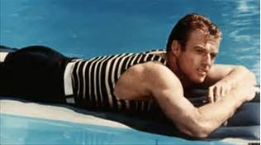
“He must have looked up at an unfamiliar sky through frightening leaves and shivered as he found what a grotesque thing a rose is and how raw the sunlight was upon the scarcely created grass.” There is some nice poetic imagery and figurative language in this sentence. Nick is putting himself in Gatsby’s shoes, trying to imagine what it must have felt like to realize that everything that Gatsby valued most was lost to him. The rose is a metaphor for his relationship with Daisy, which wasn’t as wonderful as he thought it was. Think about what the harsh sun would do to new grass. That is how Nick imagines Gatsby must have felt.
Fortuitously- happening by accident or by chance
“The chauffeur-he was one of Wolfsheim’s protégés-heard shots-afterward he could only say that he hadn’t thought anything much about them.” Does this sound strange?
“There was a faint, barely perceptible movement of the water as the fresh flow from one end urged its way toward the drain at the other with little ripples that were hardly the shadows of waves, the laden mattress moved irregularly down the pool.” As spectacular as Gatsby’s life may have been, the end of it hardly created a ripple; in fact, it was barely noticeable.
Corrugated- rippled
Holocaust- destruction; tragedy
Chapter Nine
“After two years I remember the rest of that day, and that night and the next day, only as an endless drill of police and photographers and newspaper men in and out of Gatsby’s front door.”- The final chapter is written as a recollection by Nick, about two years after the death and funeral of Gatsby. This quote is reminiscent of Daisy’s “morbid” question in Chapter 7: “"What’ll we do with ourselves this afternoon, and the day after that, and the next thirty years?” Apparently, Nick will spend his time remembering his friend, and reliving the events surrounding Gatsby’s death.
Adventitious- an outside source
“When Michaelis’s testimony at the inquest brought to light Wilson’s suspicions of his wife I thought the whole tale would shortly be served up in racy pasquinade…”- A pasquinade is something that is written to make fun of or criticize someone. Nick feared that the newspapers would jump at the chance to portray Gatsby’s murder as the result of a racy love triangle involving Mr. & Mrs. Wilson.
“I found myself on Gatsby’s side, and alone.”- It is hard to believe that a man who hosted so many crowded parties could be so quickly forgotten, but the sad truth is that West Egg people, and the upper class in New York are selfish and ignorant with regards to manners and morals.
Surmise- guess
“I went back to the drawing-room and thought for an instant that they were chance visitors, all these official people who suddenly filled it. But, as they drew back the sheet and looked at Gatsby with unmoved eyes, his protest continued in my brain…”- Nick hears people entering the room where Gatsby’s body is being kept and he hopes that people are finally coming to say goodbye to him. Then he sees it is just more officials (police, and photographers) who couldn’t care less about Gatsby’s death, Nick imagines his friends disappointment at the poor showing.
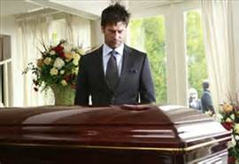
Superfluous- excessive; more than necessary
Addenda- plural of addendum, which is an item of additional material
“I think it was on the third day that a telegram signed Henry C. Gatz arrived from a town in Minnesota.”- This is a religious allusion to the resurrection of Jesus Christ. With the arrival of Henry Gatz, we have a sort of “resurrection” of James Gatz, the real boy with the real dreams of self-improvement and success.
Ulster- a long, heavy overcoat
Unpunctual- not prompt
James J. Hill- J.J. Hill was sometimes called the “Empire Builder.” He originally came from a working class background but attained wealth and glory by becoming a railroad executive and the CEO of The Great Northern Railroad during the 1800’s. Mr. Gatz believes that his son’s hard work and self-improvement is proof that Gatsby, like Hill, would have contributed something positive to the country. Nick, who knows of Gatsby self-serving criminal activity, can only uncomfortably agree.

Ejaculated- exclaimed

The Swastika Holding Company- Wolsheim is Jewish so it would seem inappropriate for his company to bear the Nazi insignia, but this meaning would be anachronistic for the time, as the swastika didn’t become a national symbol for the Nazi party and wasn’t incorporated into the flag until 1933, when Hitler came into power. The Great Gatsby was published on April 10,1925, so this mention isn’t a political reference, it was just included as a description of a decoration.

Indignantly- angry at the unfairness

Reverent- respectful

“He ate more than four dollars’ worth of food in a half an hour.”- Four dollars in the 1920s would be worth roughly $53 USD today. Gatsby was not afraid to spend money even when he didn’t have any.

“Start him! I made him!”- Meyer Wolfsheim tries to take credit for Gatsby’s success, and while it is true that Wolfsheim may have introduced Gatsby to the world of crime, it was actually Dan Cody who helped Gatsby re-invent himself.

American Legion- An organization, founded in 1919, that was formed to provide social opportunities and aide for veterans of America’s armed forces.

Bulbous- round, swollen looking

“Let us learn to show our friendship for a man when he is alive and not after he is dead.” Wolfsheim’s advice sounds pretty good, until one realizes that this is his excuse for washing his hands of Gatsby by not going to his funeral.

“Of course we was broke up when he run off from home, but I see now there was a reason for it.” The purpose of Mr. Gatz’s poor grammar usage is to emphasize his uneducated and humble background. Gatz “was broke up” or upset with his son for leaving, but now realizes that it was a good decision.

Lingeringly- reluctantly

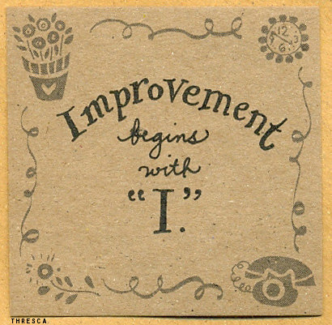
Hopalong Cassidy- Hopalong Cassidy is a fictional cowboy hero created in 1904 by the author Clarence E. Mulford, who wrote a series of popular short stories and twenty-eight novels based on the character.

“On the last fly-leaf was printed the word SCHEDULE and the date September 12, 1906.”- It is suggested that many people shaped Gatsby’s life. After showing him what life could be like, Dan Cody became Gatsby’s inspiration; Daisy was his motivation for obtaining wealth; and Meyer Wolfsheim was the means by which Gatsby gained his profits. The schedule is important because it shows that the desire to become something better came from James Gatz himself, who, even as a child, was obsessed with his own self-improvement.
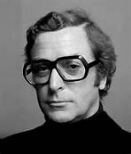
“It was the man with the owl-eyed glasses whom I had found marveling over Gatsby’s books in the library one night three months before.”- An owl is symbolic of wisdom, while the man’s glasses (and sight in general) symbolize the clarity with which individuals in the novel perceive the rest of the world. The man with the owl-eyed glasses, who hovers on the fringe of all the parties, seems to have an acute awareness of those in the inner circle. He is the only character, besides Nick, who saw past Gatsby’s facade to recognize the real man, and he is the only other “friend” to attend Gatsby’s funeral. With Gatsby dead, things seem unclear. What both men knew about their world has changed. This is symbolically implied by Owl-Eyes wiping his glasses during the funeral. Now, even those who did see the world accurately, have trouble differentiating between the real and unreal, the good and the bad.
“Why my God! They used to go there by the hundreds.”- A person from the East Egg had generational wealth that came with a name so old as to be ingrained in the public mindset. Gatsby tried to spread his name by throwing lavish parties that appealed to hundreds of superficial friends who “accepted his hospitality and paid him the subtle tribute of knowing nothing whatever about him.” Therefore, when he died, it was not as though a person died, but rather as though a long party had come to a close, and no one wanted to clean up or see the aftermath.
“One of my most vivid memories is of coming back West from prep school and later from college at Christmas time.”- Nick is having a nostalgic flashback of his childhood, and begins to describe his home to the reader. Nick once thought that the East was superior to his birthplace, but he begins to reevaluate this impression when he realizes that the East really represents materialism, corruption, and superficiality. His flashback leads him to conclude that the wholesome, innocent, and pure qualities of the Midwest really are more to his taste after all.

Gayeties- festivities
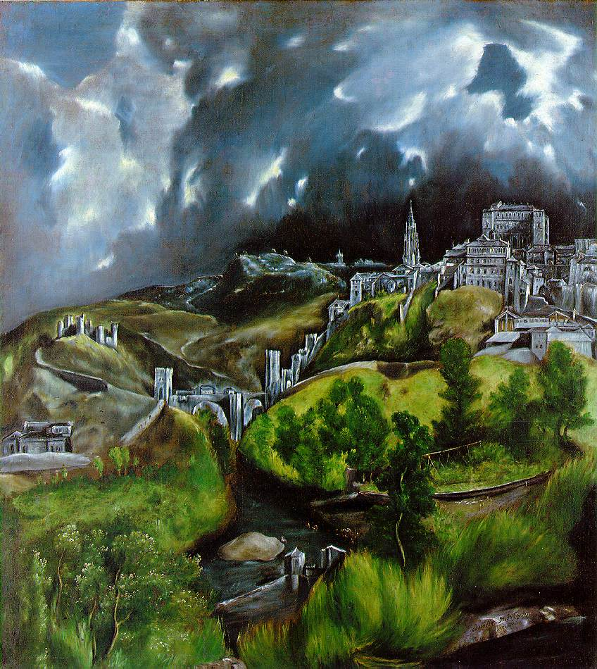
Indistinguishably- not able to tell apart

Complacent- Satisfied
El Greco- El Greco was a renowned painter, architect and sculptor of the Spanish Renaissance. Fitzgerald may have been thinking of El Greco’s landscape painting View of Toledo.

“After Gatsby’s death the East was haunted for me like that, distorted beyond my eyes’ power of correction. So when the blue smoke of brittle leaves was in the air and the wind blew the wet laundry stiff on the line I decided to come back home.”- Shortly after Gatsby’s death, Nick, who cannot find any redeeming qualities or aspects in the East, decides to return home to the virtuous and moral Midwest.
Refuse- garbage
Jauntily- lively

“When I had finished she told me without comment that she was engaged to another man. I doubted that…but I pretended to be surprised.”- Has Jordan really been seeing another man on the side this whole time, or is she just telling Nick this to save face?
“You said a bad driver was only safe until she met another bad driver? Well, I met another bad driver, didn’t I? I mean it was careless of me to make such a wrong guess. I thought you were rather an honest, straightforward person. I thought that was your secret pride.”- Here a bad driver refers to the bad decisions people make in life. Jordan is incurably dishonest, thus making her one of those bad drivers, but despite Nick’s reputed honesty, he is a bad driver too because he led her to believe that the two had a future and that their relationship was going somewhere.
“’I’m thirty,’ I said. ‘I’m five years too old to lie to myself and call it honor.”- Nick realizes that he was lying to himself about Jordan’s character. Maybe he doesn’t want to make the same mistake that Gatsby did by fancying himself in love with the wrong woman.
"What's the matter, Nick? Do you object to shaking hands with me?" "Yes. You know what I think of you."- This is really the only time Nick ever stands up for himself against Tom, which shows that Nick has grown and changed as a character. Nick won’t shake Tom’s hand because he knows that Tom was partially responsible for what happened to Gatsby.
“They were careless people, Tom and Daisy--they smashed up things and creatures and then retreated back to their money or their vast carelessness, or whatever it was that kept them together, and let other people clean up the mess they had made...”- This description of Tom and Daisy is reminiscent of the partygoers who came and carelessly destroyed Gatsby’s house without regard for anything but their own enjoyment. The Roaring 20’s was a time of carefree amusement, when people felt free to indulge themselves and refused feel any guilt for their reckless behavior, or to accept the consequences of their actions. Instead, those, who could, hid behind their shield of money. This is one thing that both the new and established rich had in common, because money, once one acquired it, gave a person the ability to be reckless and get away with it.
“I shook hands with him; it seemed silly not to, for I felt suddenly as though I were talking to a child.”- Why does Nick think of Tom as a child?
Provincial- unsophisticated
Squeamishness- easily upset
“I went over and looked at that huge incoherent failure of a house once more.”- Gatsby’s house is referred to an incoherent failure of a house because it does not fit into the neighborhood and stands out among the other houses on West Egg. Gatsby’s house also serves as a metaphor for Gatsby in society because he cannot fit in to the old wealth society no matter how hard he tries or how much effort he puts into appearing aristocratic.
Raspingly- scraping
Pandered- indulge somebody’s weaknesses
Transitory- not permanent
Aesthetic- pleasing in appearance
Commensurate- equal in size
Brooding- contemplating
“Gatsby believed in the green light [The American Dream], the orgastic [exciting] future that year by year recedes [disappears] before us. It eluded us then, but that’s no matter-tomorrow we will run faster, stretch out our arms farther [like Gatsby who reaches out for the green light]…And one fine morning-”- This quote ends with an aposiopesis, a figure of speech where a sentence is deliberately broken off and left unfinished, the ending to be supplied by the imagination, giving an impression of unwillingness or inability to continue. According to Nick, each morning, we, like Gatsby, will awake and discover that the American Dream was only a dream, an illusion of the mind.
“So we beat on, boats against the current, borne back ceaselessly into the past.”- Fitzgerald’s novel does not end on a happy note, but begs the reader to reflect upon human nature. Gatsby’s life long quest to transcend his past was ultimately futile. In comparing this backward driving force as a current, Fitzgerald presents our fate as unavoidable and predetermined. According to this last line, it is the inescapable lot of humanity to move backward. Any attempt at progress is the result of excessive arrogance and misplaced ambition.
Fun Fact
In Chapter Three, at Gatsby's first party, Jordan places a call to her elderly aunt, her only living relative, Miss Sigourney Howard (perhaps named by Fitzgerald after his friend, Father Sigourney Fay, a Roman Catholic priest). After reading The Great Gatsby, actress Susan Weaver borrowed the name and became Sigourney Weaver, best known for her role as Ellen Ripley in the "Alien" sci-fi movie trilogy.

